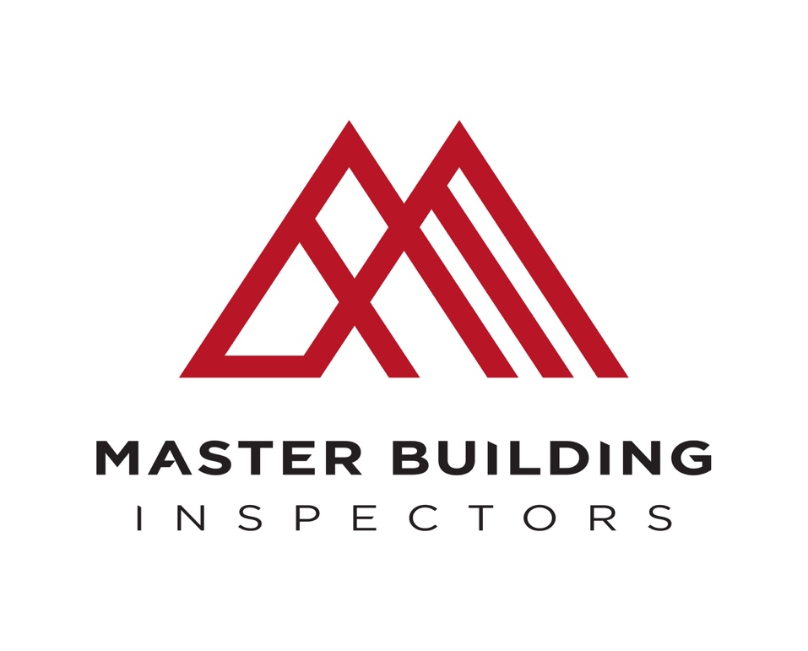

ASBESTOS INSPECTION AND CONDITION REPORT

Inspection Date:

Property Address:

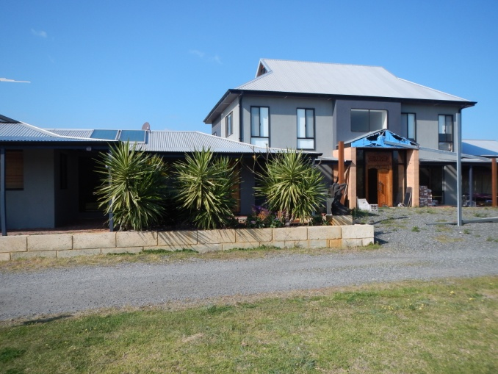

Contents

I. About this report 3

A. Report details 3

B. Special conditions or instructions 3

C. Important information to help you interpret this report 3

1. Defined terms 3

2. Scope, exclusions and limitations 3

3. Recommendations in this report 4

II. Results of your property inspection 4

A. Summary 4

1. Our view on the condition of the Property 4

2. Table of defects 4

B. General description of the Property 4

C. Accessibility 5

1. Areas Inspected 5

2. Obstructions and Limitations 5

3. Undetected defect risk assessment 5

III. Significant items 6

IV. Conclusion- Assessment of overall condition of property 6

V. Understanding this report- defintions 7

VI. Scope, limitations and exclusions 10

A. SERVICE 10

B. PURPOSE 10

C. SCOPE OF INSPECTION 10

D. Limitations 11

E. Exclusions 12

f . Other Important points to note 13

# About this report

## Report details

|  |  |
| --- | --- |
| Report on (address) (the **Property**): |  |
| Client name (the **Client** or **you**): |  |
| Client's phone number: |  |
| Client's email address: |  |
| Building inspector: | Joshua Briggs |
| Builder's registration number: | 101288 |
| Company name: | Master Building Inspectors |
| Company address and postcode | Po Box 6249 Swanbourne WA 6010 |
| Company email address | info@masterbuildinginspectors.com.au |

If you would like to discuss any aspect of this report please contact:

Joshua Briggs

0415 237 273

info@masterbuildinginspectors.com.au

## Special conditions or instructions

A report may be conditional on information provided by a person, agents or employees of the person requesting the report, apparent concealment of possible defects and a range of other factors.

|  |  |
| --- | --- |
| **Special condition/instruction** | **Comments** |
|  |  |

## Important information to help you interpret this report

### Defined terms

This report uses the terms defined in Section V. Where capitalised terms appear in this report you should give those terms the same meaning as set out in Section VI.

### Scope, exclusions and limitations

You should read Section VI of this report in full. Section VII explains the scope of this report and the exclusions and limitations which apply to it. When reading this report you should interpret it in light of the exclusions and limitations set out in Section VI.

### Recommendations in this report

You acknowledge that, unless stated otherwise, you should as a matter of urgency implement any recommendation or advice given in this report.

# Results of your property inspection

## Summary

This summary is not a substitute for the report, which you should read in full.

### Our view on the condition of the Property

In summary, asbestos was suspected to be present in various building materials throughout the property.

### Table of defects

The table below details the issues we identified during our inspection of the Property.

|  |  |
| --- | --- |
| **Issue** | **Details** |
| ACM - Urgent and Hazardous Condition |  |
| ACM – High Risk Condition |  |
| ACM – Low Risk Condition |  |
| ACM – Confirmed in Samples |  |

## General description of the Property

|  |  |
| --- | --- |
| Building type: |  |
| Main building floor construction: |  |
| Number of storeys: |  |
| Main building roof construction: |  |
| Main building wall construction: |  |
| Other timber building elements: |  |
| Occupancy status: |  |
| Furnished or unfurnished: |  |
| Strata or company titles: |  |
| Orientation: |  |
| Prevailing weather conditions at the time of inspection: |  |

## Accessibility

### Areas Inspected

The following areas were inspected: - As documented in your pre inspection agreement, obstructions and limitations to the accessible areas for inspection are to be expected in any inspection. Refer also to our listing of obstructions and limitations.

The inspection excludes areas which are affected by obstructions or where access is limited or unsafe. We do not move obstructions and building defects may not be obvious unless obstructions or unsafe conditions are removed or access is provided.

The following areas were inaccessible: -

Any areas which are inaccessible at the time of inspection present a high risk for undetected building defects. The Client is strongly advised to make arrangements to access inaccessible areas.

### Obstructions and Limitations

Building defects may be concealed by the following obstructions which prevented full inspection: -

The presence of obstructions increases the risk of undetected defects. The client should make arrangements to remove obstructions wherever possible and re-inspect these areas as a matter of urgency. See also overall risk rating for undetected defects.

### Undetected defect risk assessment

A risk rating to help you understand the degree to which accessibility issues and the presence of obstructions have limited the scope of inspection.

The risk of undetected defects is: -

When the risk of undetected defects is high we strongly recommend further inspection once access is provided or if the obstruction can be removed. Please contact us for further advice.

# Significant items

| **Defect type** | **Details** | **Picture of defect (where available)** | |
| --- | --- | --- | --- |
| **Defect 1** | | | |
|  | | | Oakford 002.JPG |

# Conclusion- Assessment of overall condition of property

In summary,

# Understanding this report- defintions

This Report uses the terms defined below. This means that where the capitalised terms below appear in the report you should give them the same meaning as set out below.

**Client** has the meaning given in Section I.A of this report.

**Building element** Portion of a building that, by itself or in combination with other such parts, fulfils a characteristic function. NOTE: For example supporting, enclosing, furnishing or servicing building space.

**Clearance Certificate** Clearance certificate are issued in accordance with Regulation 474. The licensed asbestos assessor or competent person must ensure that the asbestos removal area does not pose a risk to health and safety from exposure to asbestos.

**Clearance Inspection** Clearance Inspections are carried out by a licensed asbestos assessor after asbestos removal hasbeen commissioned at a workplace. The licensed assessor must ensure that the asbestos removalarea does not pose a risk to health and safety from exposure to asbestos.

**Client** The person or other entity for whom the inspection is being carried out.

**Competent Person** (WHS Regulations)A competent person means:

(f) for a clearance inspection under regulation 473, a person who has acquired through training or experience the knowledge and skills of relevant asbestos removal industry practice and holds:

(i) a certification in relation to the specified VET course for asbestos assessor work or

(ii) a tertiary qualification in occupational health and safety, occupational hygiene, science, building, construction or environmental health

(g) for any other case, a person who has acquired through training, qualification or experience the knowledge and skills to carry out the task.

**Defect** Fault or deviation from the intended condition of a material, assembly, or component.

**Encapsulation** (Asbestos) Encapsulation of Asbestos Containing Materials is a general term for management strategies which may be advised. Depending on the product and location of it encapsulation will usually involve the application of a sealant product. Encapsulation by the use of partitions is not advised or generally allowable. Refer to your Inspector for more advice, encapsulation should always be undertaken by a trained and experienced and where required licensed technician.

**Friable Asbestos** Friable asbestos means material that:

(a) is in a powder form or that can be crumbled, pulverised or reduced to a powder by hand pressure when dry and

(b) contains asbestos.

**In-Situ Asbestos** In situ asbestos means asbestos or ACM fixed or installed in a structure, equipment or plant, but does not include naturally occurring asbestos.

**Inspection** Close and careful scrutiny of a building carried out without dismantling, in order to arrive at a reliable conclusion as to the condition of the building.

**Inspector** Person or organisation responsible for carrying out the inspection.

**Licensed Asbestos Assessor** Licensed asbestos assessor means a person who holds an asbestos assessor licence.

**Licensed Asbestos Removal Work** Licensed asbestos removal work means asbestos removal work for which a Class A asbestos removallicence or Class B asbestos removal licence is required.

**Licensed Asbestos Removalist** Means a person conducting a business or undertaking who is licensed under these Regulations tocarry out Class A asbestos removal work or Class B asbestos removal work.

**Limitation** Any factor that prevents full or proper inspection of the building.

**Major - Asbestos** A Major Defect in the context of an Asbestos Inspection and Condition Report is any Asbestos or ACM which is present in the building, in a poor condition or in a high risk situation. This may include but is not limited to Asbestos or ACM which has a higher probability of airborne fibre release due to age of materials, material deterioration, damage or probability of damage and degree of human interaction with or access to the element.

**Membrane Filter Method** Membrane filter method means the membrane filter method described in the Guidance Note on theMembrane Filter Method for Estimating Airborne Asbestos Fibres [NOHSC:3003 (2005)].

**Minor - Asbestos** Minor in the context of an Asbestos Inspection relates to Asbestos which is found to be present in thebuilding or on the site but that is in comparatively good condition with a low probability of fibre release.For example the Asbestos or ACM could be in a low traffic area, with little probability of interaction oruse and is in good, encapsulated or sealed condition.

**NATA** NATA means the National Association of Testing Authorities, Australia.

**NATA Accredited Laboratory** NATA-accredited laboratory means a testing laboratory accredited by NATA, or recognised by NATAeither solely or with someone else.

**Naturally Occurring Asbestos** Naturally occurring asbestos means the natural geological occurrence of asbestos minerals found inassociation with geological deposits including rock, sediment or soil.

**Non-Friable Asbestos** Non-friable asbestos means material containing asbestos that is not friable asbestos, includingmaterial containing asbestos fibres reinforced with a bonding compound.Note: Non-friable asbestos may become friable asbestos through deterioration (see definition of friableasbestos).

**Readily Accessible Areas** Areas which can be easily and safely inspected without injury to person or property, are up to 3.6metres above ground or floor levels, in roof spaces where the minimum area of accessibility is not lessthan 600 mm high by 600 mm wide and subfloor spaces where the minimum area of accessibility isnot less than 400 mm high by 600 mm wide, providing the spaces or areas permit entry. The term'readily accessible' also includes:

(a) accessible subfloor areas on a sloping site where the minimum clearance is not less than 150mm high, provided that the areas is not more than 2 metres from a point with conforming clearance (i.e. 400 mm high by 600 mm wide) and

(b) areas at the eaves of accessible roof spaces, that are within the consultant's unobstructed line of sight and within arm's length from a point with conforming clearance (i.e. 600 mm high by 600mm wide).

**Reasonably Practicable** In the WHS Act, reasonably practicable, in relation to a duty to ensure health and safety, means thatwhich is, or was at a particular time, reasonably able to be done in relation to ensuring health andsafety, taking into account and weighing up all relevant matters including:

(a) the likelihood of the hazard or the risk concerned occurring and

(b) the degree of harm that might result from the hazard or the risk and

(c) what the person concerned knows, or ought reasonably to know, about:

(i) the hazard or the risk and

(ii) ways of eliminating or minimising the risk and

(d) the availability and suitability of ways to eliminate or minimise the risk and

(e) after assessing the extent of the risk and the available ways of eliminating or minimising

the risk, the cost associated with available ways of eliminating or minimising the risk, including whether the cost is grossly disproportionate to the risk.

**Respirable Asbestos Fibre** Respirable asbestos fibre means an asbestos fibre that:

(a) is less than 3 micrometres wide and

(b) more than 5 micrometres long and

(c) has a length to width ratio of more than 3:1.

**Roof space** Space between the roof covering and the ceiling immediately below the roof covering.

**Safety Hazard -Asbestos** Asbestos categorised as a safety hazard within the context of an Asbestos Inspection and ConditionReport is Asbestos which due to its degraded condition, damage or any other factor in the opinion ofthe inspector requires immediate and urgent application of management strategies to minimise risk offurther airborne fibre release until a more suitable strategy for its removal or encapsulation is made.

**Significant item** An item that is to be reported in accordance with the scope of the inspection.

**Structural defect** Fault or deviation from the intended structural performance of a building element.

**Structural element** Physically distinguishable part of a structure. NOTE: For example wall, columns, connection.

**Subfloor space** Space between the underside of a suspended floor and the ground.

# Scope, limitations and exclusions

## SERVICE

As requested by the Client, the inspection carried out by the Building Consultant was an Asbestos Inspection and condition Report. A pre- inspection agreement was issued for this service and forms part of the service agreement.

## PURPOSE

The purpose of this inspection is to provide a person or entity with advice from a competent person regarding the identification of suspected Asbestos, Asbestos Containing Material (ACM) and Asbestos Containing Dust (ACD) and where present its condition. Where sampling is included, the positive confirmation of the presence of asbestos based on samples removed is also included.

## SCOPE OF INSPECTION

The inspection shall comprise visual assessment of the property and where requested limited sampling to identify Asbestos, ACM and or ACD to form an opinion regarding the presence or absence of Asbestos and its general condition at the time of inspection.

The inspection was limited to Readily Accessible Areas of the Building and Site. The Client shall arrange right of entry, facilitate physical entry and supply necessary information to enable the inspector to undertake the inspection and prepare a report.

The Inspector is not responsible for arranging entry to property or parts of the property where reasonable access or entry is denied those areas are excluded from and do not form part of the inspection. The Client is responsible for provision of permissions to take all samples from all sites as reasonably requested by the Inspector. Where permission to take a sample is withheld the Inspector cannot confirm the presence of Asbestos and therefore its presence must be assumed until disproved.

**ACCEPTANCE CRITERIA**

The Property was compared with a Property that was constructed in accordance with the generally accepted practice at the time of construction and which has been maintained such that there has been no significant loss of strength and serviceability. Unless noted in Section I.B (Special Conditions or Instructions), the Report assumes that the existing use of the building will continue.

This Report only records the observations and conclusions of the Building Consultant about the readily observable state of the Property at the time of inspection. The Report therefore cannot and does not deal with:

(a) possible concealment of defects, including but not limited to, defects concealed by lack of accessibility, obstructions such as furniture, wall linings and floor coverings, or by applied finishes such as render and paint; and

(b) undetectable or latent defects, including but not limited to, defects that may not be apparent at the time of inspection due to seasonal changes, recent or prevailing weather conditions, and whether or not services have been used some time prior to the inspection being carried out.

## Limitations

The Client acknowledges that:

(a) the Building Consultant will conduct a visual inspection only;

(b) this report does not include the inspection and assessment of items or matters outside the scope of the requested inspection and report. Other items or matters may be the subject of a Special-Purpose Inspection Report, which is adequately specified.

(c) this Report does not include the inspection and assessment of items or matters that do not fall within the Building Consultant’s direct expertise;

(d) the inspection only covered the Readily Accessible Areas of the Property. The inspection did not include areas, which were inaccessible, not readily accessible or obstructed at the time of inspection. Obstructions are defined as any condition or physical limitation which inhibits or prevents inspection and may include – but are not limited to – roofing, fixed ceilings, wall linings, floor coverings, fixtures, fittings, furniture, clothes, stored articles/materials, thermal insulation, sarking, pipe/duct work, builders debris, vegetation, pavements or earth;

**Sampling**

The client must provide all written permissions for the removal of samples required to confirm the presence of Asbestos. The inspector is not responsible for:

(a) Securing permissions to take samples

(b) Facilitating suitable access, which may include the creation of a 10 metre exclusion area

at the site of each sample

(c) Whilst all care will be taken in the removal of the smallest possible sample, any damage to the sample site or surrounding building material, fittings and fixtures is the responsibility of the client. Repairs and reinstatement of the sample site and any associated costs to make safe are excluded from the inspections service.

(d) Any incidental, accidental or unplanned contamination of the location or inspection site as a result of sampling is the responsibility of the client to rectify.

(e) General rectification and reinstatement of the sample sites.

## Exclusions

The Client acknowledges that this report does not cover or deal with:

This Report is not an Asbestos Register or Asbestos Management Plan (as required by WH Regulations). This is a recommended additional service for all workplaces which is available on request.

Labelling of locations with compliant safety notices (as required by WHS Regulations) is also excluded from this service. This is a recommended additional service for all workplace which is available on request.

An estimate of the costs of rectification or management costs is not required in an inspection report. The cost to rectify or repair locations of sample sites and any resultant damage is excluded from this service and is the responsibility of the client.

**Accessibility**

Unless specified in writing, the inspection only covered the Readily Accessible Areas of the Property. The inspection did not include areas, which were inaccessible, not readily accessible or obstructed at the time of inspection. Areas, which are not normally accessible, were not inspected and include - but not limited to - the interior of a flat roof or beneath a suspended floor filled with earth.

Building Interior: The consultant did not move or remove any ceilings, wall coverings, floor coverings (including carpeting and wooden floorboards), furnishing, equipment, appliances, pictures or other household goods. In an occupied property, furnishings or household items may be concealing evidence of defects, which may only be revealed when the items are moved or removed.

NOTE. In the case of strata and company title properties or other Class 2 buildings or equivalent, if the inspection was limited to assessing the interior of a particular unit or lot, the Client may have additional liability for defects in the common property. This additional liability can only be addressed through the undertaking of a special-purpose inspection report, which is adequately specified.

Building Exterior, Roof Exterior and Site: the Building Consultant did not move or remove any obstructions such as wall cladding, awnings, trellis, earth, plants, bushes, foliage, stored materials, debris or rubbish, etc. Such items may be concealing defects, which may only be revealed when the items are moved or removed.

## f . Other Important points to note

Special attention should be given to this Section VI of this report.

This Report only records the observations and conclusions of the Consultant about the readily observable state of the property at the time of inspection.

If the Client has any doubt about the purpose, scope and acceptance criteria on which this

Report was based please discuss your concerns with the Consultant on receipt of this

Report. The Client acknowledges that, unless stated otherwise, the Client as a matter of urgency should implement any recommendation or advice given in this Report.